Configuring Elastic Container Service

**Create a Fargate Cluster.**

Let’s open the AWS management console for this step.

* Search for Elastic Container Service and select Elastic Container Service.
* From the left menu select Clusters
* Select Create cluster
* Under Select cluster template we are going to select networking only. We don’t need ec2 instances in our cluster because Fargate will take care of spinning up compute resources when we start our task and spinning them down when we stop our task.

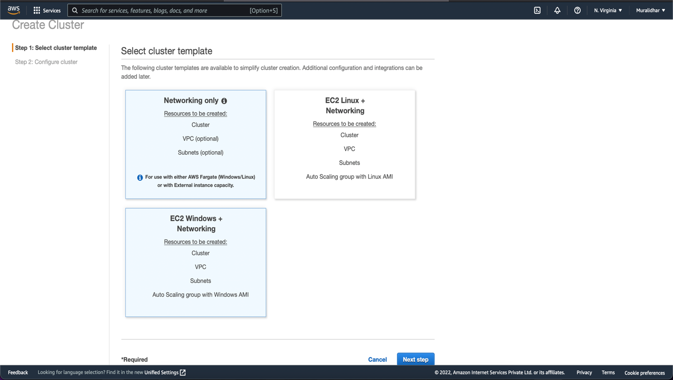

name the cluster **orderbird-cluster**, and the rest we can leave as is. And select create

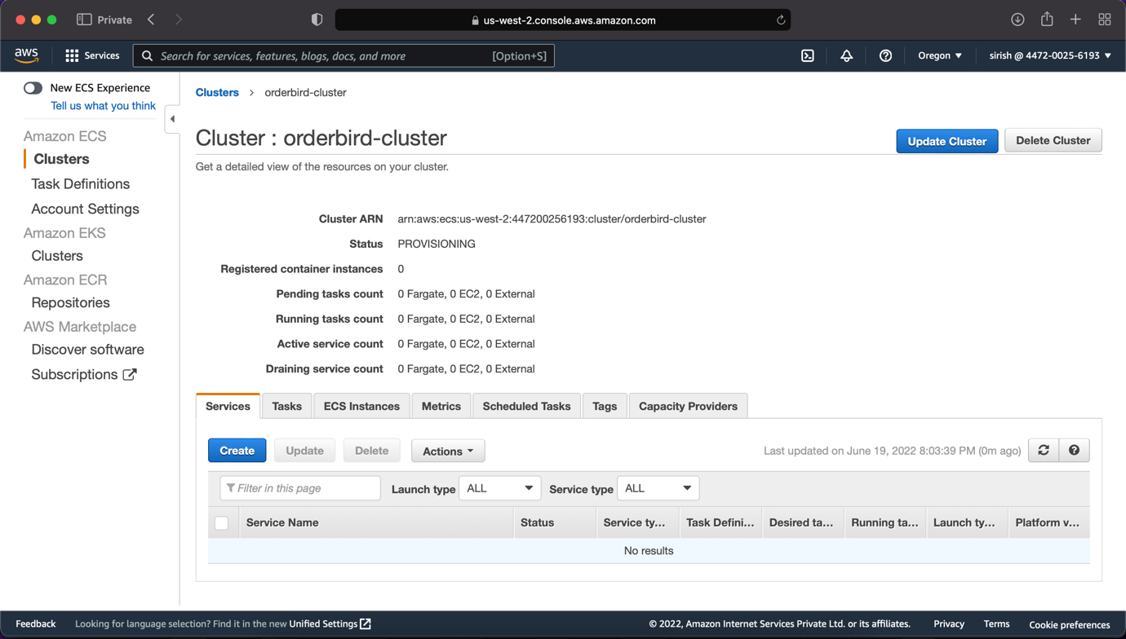

## Create an ECS Task

The ECS Task is the action that takes our image and deploys it to a container. To create an ECS Task lets go back to the ECS page and do the following:

* Select **Task Definitions** from the left menu. Then select **Create new Task Definition**
* 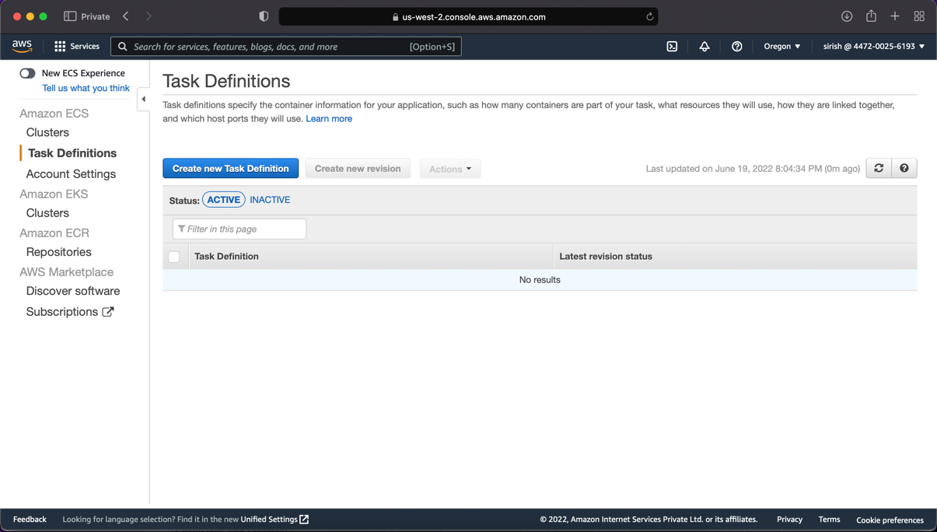



* Select **Fargate** and select **create**

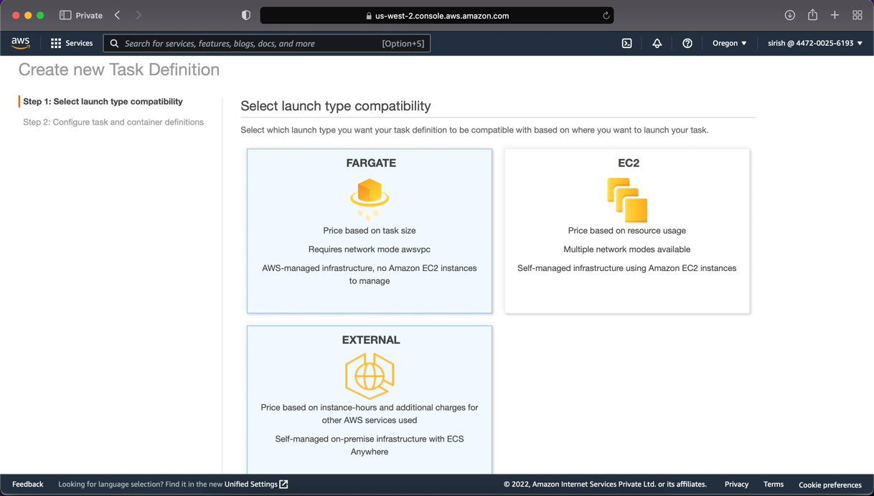

* Enter a name for the task. I am going to use orderbird.
* Leave Task Role and Network Mode set to their default values.
* For Task memory and Task CPU select the minimum values. I need minimal resources for this test.

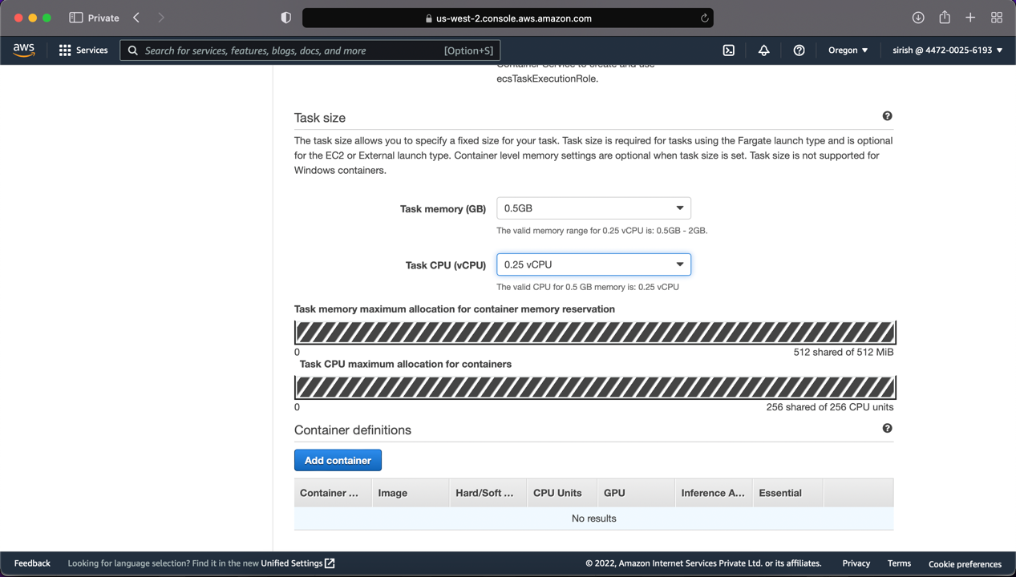

* Under Container definition select Add Container.
* Enter a Container name. I will use orderbird again.
* In the Image box enter the ARN of our image. And keep the Memory Limit to 128Mb
* Whatever port we enter here will be opened on the instance and will map to the same port on container. We will use 5000 because that is where our app listens.

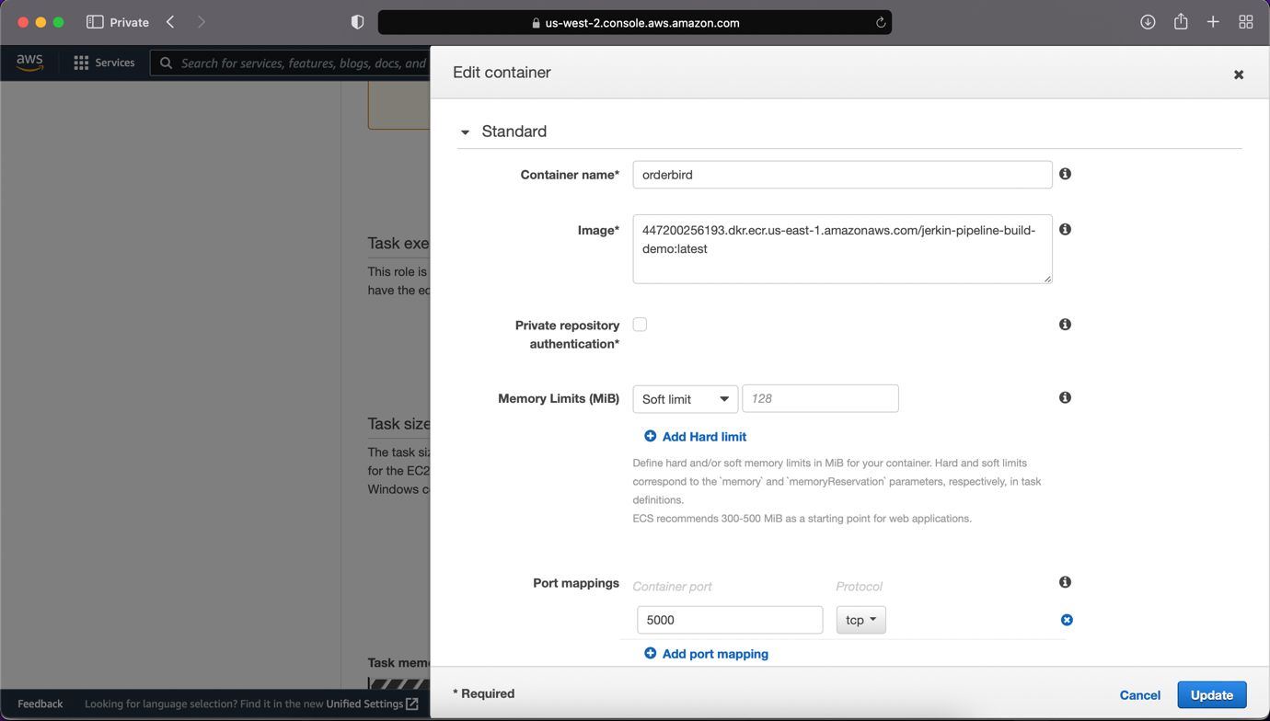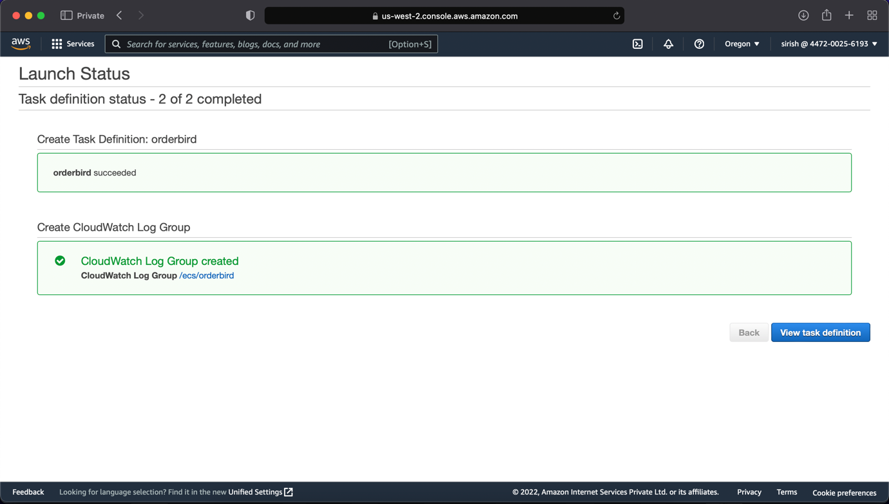

* Leave everything else set to its default value and click Add in the lower left corner of the dialog.
* Leave everything else in the Configure task and container definitions page as is and select Create in the lower left corner of the page.
* Go back to the ECS page, select **Task Definitions** and we should see our new task with a status of ACTIVE.

**Run the ECS Task!**

* This is the moment we have all been waiting for.
* Select the task in the Task definition list
* Click **Actions** and select **Run Task**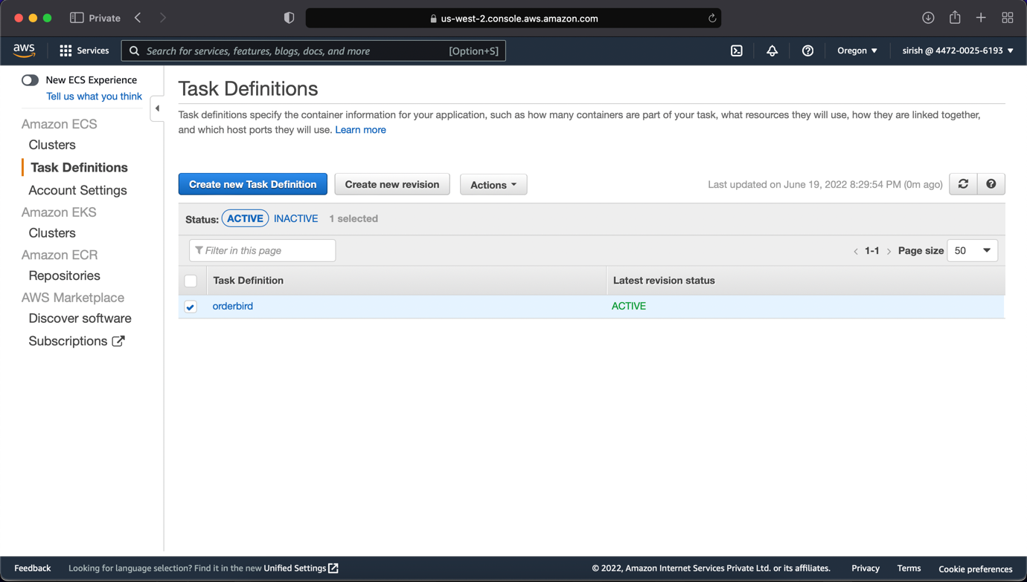
* For Launch type: select **Fargate**
* Make sure Cluster: is set to orderbird we created earlier.

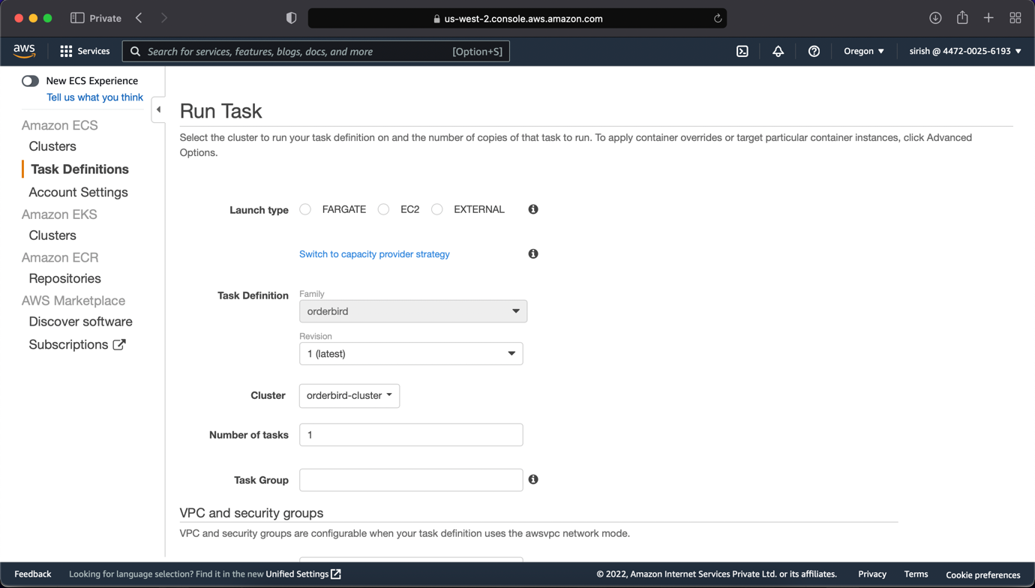

* select a VPC from the list.
* Add at least one subnet.
* Auto-assign public IP should be set to ENBABLED

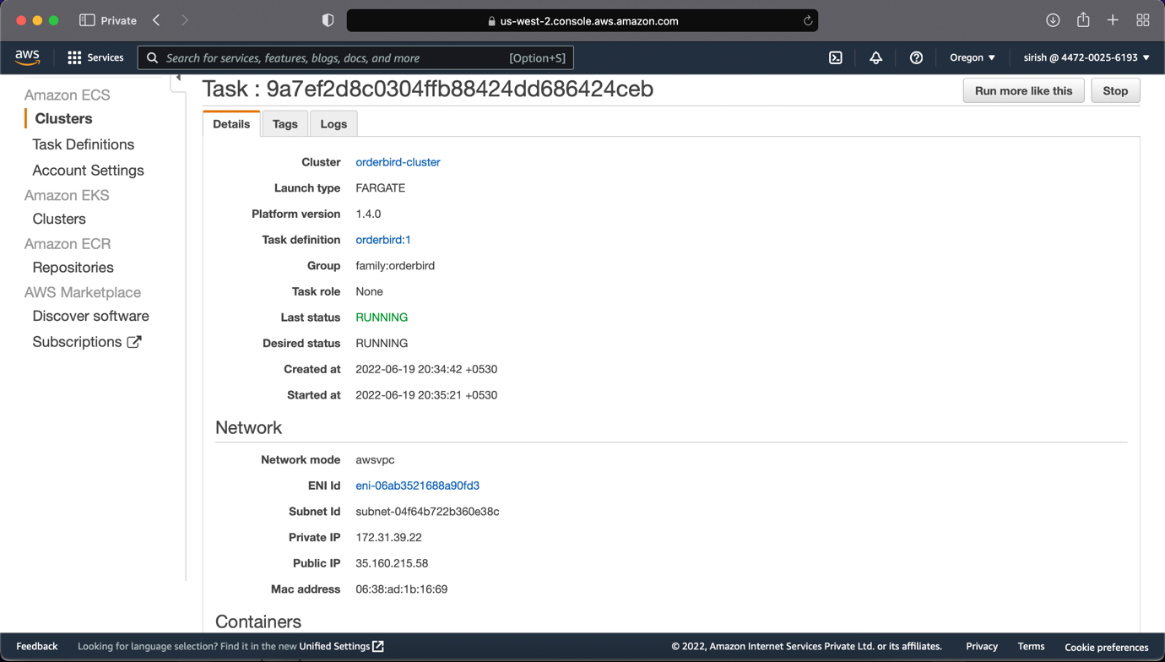

Check the Public IP address with port 5000

